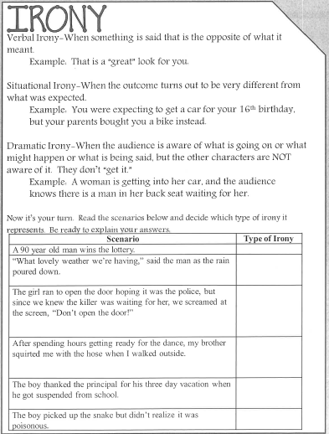
Directions: Review the following irony terms to refresh your memory of each and then complete the assignments that follow.
