PIFEL-SOCIAL STUDIES A-PERIOD 4-OFFSITE LEARNING PACKET-DAY 6
INSTRUCTIONS
- Students, click the blue link in each of the “Resources” boxes below. Use the resources they provide, (slideshow, video, reading, etc) to answer the questions in the “Questions” boxes.
- Use “Control + Click” to open link
- Use the space in the “Questions” box to type your answers in.
- If questions are multiple choice, change the font of the correct response, or responses to RED to indicate they are your selection(s)

9-Week Course

1.2 Teens and Taxes

Student Activity Packet

Name:

In this lesson, you will learn to:
- Explain why so few teenagers file taxes
- Identify common misconceptions about taxes and state the correct facts
- Determine whether you need to file taxes based on a variety of scenarios
- Identify what types of income are taxed

Resources | Questions
1 How Old Are Most Taxpayers? Analyze the chart and answer the questions on this worksheet to complete this Data Crunch. Then, have a brief class discussion based on your findings - your teacher will ask you questions to guide you. | Estimated time: 10 mins  Chart and Five Questions are included in this document below.
2 Updated Tax Figures Throughout this lesson, you may notice that tax figures vary based on the year the resource was created. Review this slide and make note of the most updated figures in the section to the right before proceeding with the lesson. | Estimated time: 3 mins  Chart included below  What is the Standard Deduction?
3 Tax Facts (How Much Do You Know About Tax Day?) How much do teens really know about taxes? What are some important tax facts teens should know? Watch this video to find out. Then, answer the questions to the right.  Youtube link:  https://www.youtube.com/watch?v=UWh209IPgwo | Estimated time: 7 mins  - How does your tax knowledge compare to the majority of the teens’ tax knowledge in the video?  - As you learned in the video, there is no specific age requirement to pay taxes. Why, then, do you think there is a lack of awareness and general knowledge about taxes among teens?
4 Tax Issues that Impact Working Teens & Their Parents As a teenager, you’re likely being claimed as a dependent on your parent’s taxes, so do you need to pay and/or file taxes yourself? What about jobs that are considered “off-the-books,” where you are paid in cash and don’t receive a paycheck or W-2? Read this article about the tax requirements for some classic teen jobs. Then, answer the questions. NOTE: This article has information from 2018. Use the values from Resource 2 for updated tax figures.  Link to article:  https://www.bankrate.com/finance/taxes/teen-jobs-and-tax-issues-1.aspx | Estimated time: 10 mins  - Stella is 16 years old. She earned $3,500 this year at a local ice cream shop, and another $3,500 in cash babysitting her neighbor’s son. Does she need to file a tax return? Why or why not?  - Review the jobs listed below and determine whether you would be a “household employee” or “self-employed”.  Job “Household Employee” or “Self-Employed”  Babysitter  Selling Lemonade  Designing Websites  Gardening Neighbor’s Yard  Dog Walker  3. If Jose earns $1700 this year selling t-shirts he screenprints in his garage, what taxes would he need to pay?
5 PLAY: Should They File a Tax Return? Put all you’ve learned so far to the test in this fun activity! Follow your teacher’s directions on how to complete this activity. Link to Slide Show: https://docs.google.com/presentation/d/1G2NPel0z3d-mR48ziqMkzQtvxA6ih1CxOgdK0l7yvAU/edit#slide=id.g44b551e331_974_0 | Estimated time: 10 mins  Follow the link to the slideshow. Complete the chart below stating whether each of the 13 people are required to file a tax return.
6 Exit Ticket Follow your teacher’s directions to complete the Exit Ticket. | Estimated time: 5 mins  Do you need to file a tax return?  Why or why not?

How Old Are Most Taxpayers?
Data Crunch
Taxes #1
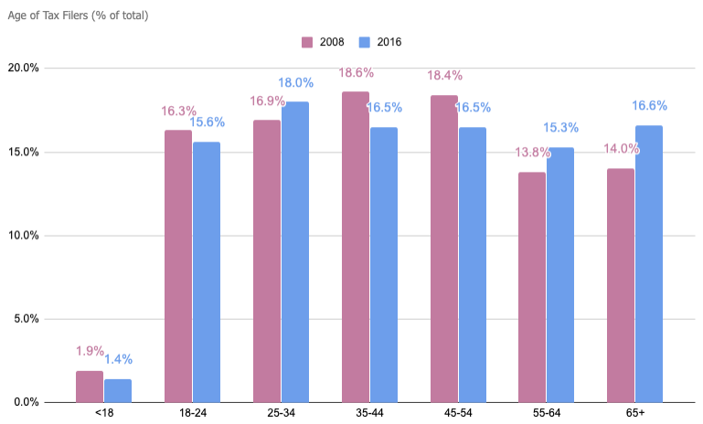

- What age group represents the highest percentage of taxpayers in 2016?  DOK 1 | - What age groups have seen the sharpest increase as a percentage of taxpayers from 2008 to 2016?  DOK 1
- Research has found that it has become more difficult for teens to find part-time and summer work. Use data from this chart to support this point.

DOK 2
- What do you think causes the percent of filers to jump so dramatically between the under-18 group and the 18-26 group?

DOK 2
- What might have to happen in the US for any dramatic changes to occur in future versions of this graph?

DOK 3

As you go through this unit, you may notice that certain tax figures vary depending on which year the resource was created in. Refer to the figures below for the most current tax year: 2019 (filing in 2020).

- Standard Deduction: $12,200
If you are a dependent, under the age of 65, and single, you must pay taxes:  - If you earned more than $12,200.  - If you receive unearned income that is more than $1,100.  - If your gross income was more than the larger of $1,100 or earned income up to $11,850 plus $350 | If you are NOT a dependent, under the age of 65, and single, you must pay taxes:  - If you earn $12,200 or more. | Regardless of dependence status:  - You must pay taxes if you’re self-employed and earn more than $400  - Contributions to all of your traditional and Roth IRAs cannot exceed your taxable compensation, with a maximum of $6,000/yr for tax year 2019.

NGPF Activity Bank

Taxes #10

Worksheet

PLAY: Should They File a Tax Return?
Name(s): ________________________________________________________________

Follow your teacher’s instructions to fill out the table below.
 | Can this person be claimed as a dependent? | Is this person legally required to file a tax return? Why or why not? | If no, should they file a tax return? Explain your reasoning.
TIM
CHRISTIAN
JESSICA
KAREEM
ABBY
LAURA
RITA
SONIA
YANELY
DAN
MASON
TORI
EUGENIE

