PIFEL-SOCIAL STUDIES B-PERIOD 7-OFFSITE LEARNING PACKET-DAY 5
INSTRUCTIONS
- Students, click the blue link in each of the “Resources” boxes below. Use the resources they provide, (slideshow, video, reading, etc) to answer the questions in the “Questions” boxes.
- Use the space in the “Questions” box to type your answers in.
- If questions are multiple choice, change the font of the correct response, or responses to RED to indicate they are your selection(s)

Semester Course

1.1 Taxes and Your Pay Stub

Student Activity Packet

Name:

In this lesson, you will learn to:
- Explain where income taxes are collected from and how they provide revenue for public expenses
- Read a pay stub and describe the different deductions

Resources | Questions
What are the top three expenses the government pays for with our tax dollars?  Discuss this question with your classmates or with a partner.  Answer the question to the right.  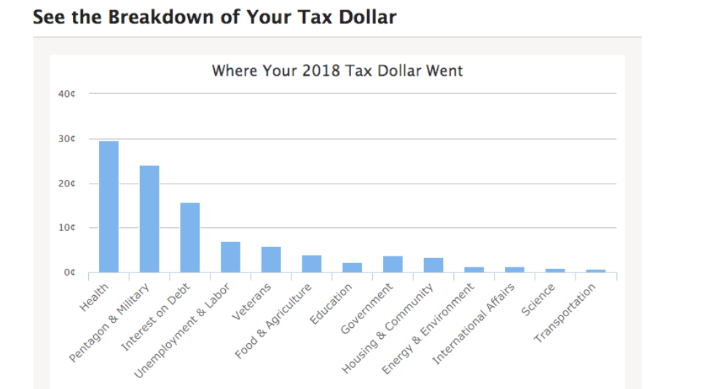 | Estimated time: 5 mins  Americans pay different kinds of taxes: income tax, sales tax, etc. What do you think are the top three categories the government spends our tax dollars on?  1.  2.  3.
If Paychecks Could Talk  Everyone pays taxes, and many people complain about them. But why?  Watch this video to learn where tax revenue comes from and what exactly the government is spending that money on.  After the video answer the questions to the right by highlighting the correct answer.  After the video answer the questions to the right by highlighting the correct answer. | Estimated time: 7 mins  - What does FICA consist of?  - Health Insurance  - Social Security Medicare  - Federal & State Taxes  - Employer Sponsored Retirement  - What are 2 examples of discretionary spending?  - Social Security  - Education  - Military  - Medicare  - All of the following options are benefits we receive as a result of government spending EXCEPT…  - Air quality  - Credit card debt forgiveness  - Public school education  - National Parks maintenance
Your Federal Income Tax Receipt  This interactive calculator allows you to see a “receipt” for your taxes, detailing exactly where your dollars were spent.  Enter your federal income taxes paid for the previous year into the calculator. If you didn’t pay federal income taxes, enter $6,388 (taxes paid for a salary of $53,891 - the median salary of a U.S. household). Then answer the questions at right. | Estimated time: 5 mins  - What’s one category you wish fewer taxes were spent on? Why?  - What’s one category you wish more taxes were spent on? Why?
How to Read a Pay Stub  Reading your pay stub can be challenging if you don’t know where to start! Watch this short video on how to read a pay stub. Then answer the questions to the right by highlighting the correct answer. | Estimated time: 3 mins  - What is the difference between gross pay and net pay?  - Gross pay is before taxes and deductions are subtracted; Net pay is your take-home pay.  - Net pay is before taxes and deductions are subtracted; Gross pay is your take-home pay.  - There is no difference between gross and net pay.  - What are Pre-Tax Deductions and Contributions?  - Contributions taken out of your paycheck BEFORE taxes are calculated on your income  - Contributions taken out of your paycheck AFTER taxes are calculated on your income  - What are two examples of Employer Contributions?  - 401k & Roth IRA  - Traditional & Roth IRA  - Federal & State Taxes  - Health Insurance & 401k
Reading a Pay Stub  It’s now time to practice reading a pay stub! Follow the directions in this interactive to complete all 3 parts of the simulation. Identify any questions you have below as you are completing the simulation. Type directly into this document. | Estimated time: 8 mins
The Fine Print: Pay Stub  Now that you’ve had some practice reading a pay stub, let’s look at a sample pay stub and put all of your skills to the test! Follow the directions on the worksheet to complete this activity. | Estimated time: 12 mins
Exit Ticket  Answer the questions on the right type directly into this document. | Estimated time: 5 mins  In your own words, explain why we pay taxes.  Identify two deductions you will see on your pay stub.  Distinguish between net pay and gross pay.

